
Deputy Principal
Application Pack 2025


INTRODUCTION TO THE APPLICATION PACK
Thank you for expressing interest in the position of Deputy Principal at Campbells Bay Primary School. The following documents and information are included for your application:
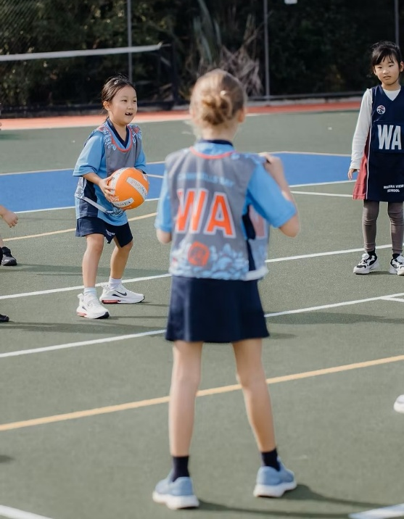
- Application Pack
    - Introduction to the Application Pack
    - School Profile
    - Criteria for the Appointment
    - Information for Applicants
    - Recruitment Process Timeline
    - Job Description
- Application Form (a separate document)
- Referee Report (a separate document)
Further information about Campbells Bay Primary School can be found on the school website: https://www.campbellsbay.school.nz
The application for appointment is to be returned with your Curriculum vitae (CV) and covering letter by 1:00 pm 17th November 2025
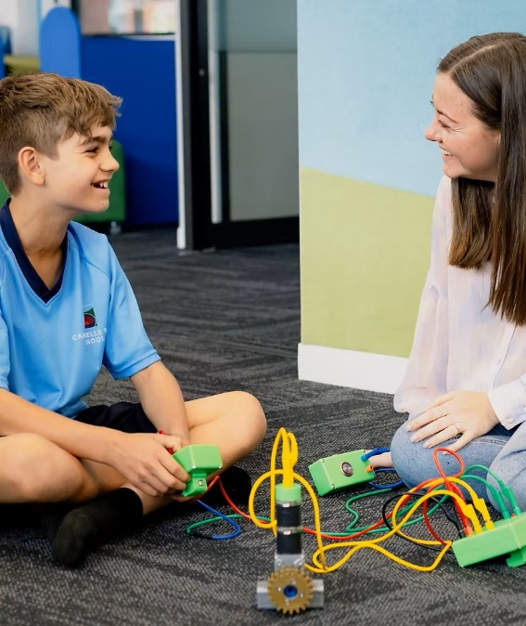
Email to: admin@educationgroup.co.nz (subject line: Campbells Bay Primary School Deputy Principal position); OR Deliver to: Tanya Prentice, Office Manager, The Education Group Ltd, Level 2, 24 Manukau Road, Epsom
Referee report forms are to be given to your three referees for them to return directly to The Education Group Ltd by 1:00 pm 17th November 2025.
For any further queries please contact Tanya Prentice at The Education Group office (Ph: 09 953 0523) email admin@educationgroup.co.nz; or Karen Smith, the Appointment Advisor (Ph: 027 202 4211) email karensmith@educationgroup.co.nz
Once again, thank you for your interest in applying for this position.
Ngā mihi
Karen Smith
Director
The Education Group
Appointment Advisor to the Campbells Bay Primary School Board


SCHOOL PROFILE

Campbells Bay School is a large, high-performing contributing primary school on Auckland's North Shore, set in park-like grounds that feature a treasured community forest. Guided by the vision "Growing learners who strive to be the best they can be" (He poipoi i te tamaiti kia eke ai ki tōna pito mata), the school is committed to nurturing the potential of every child. This vision is built on a foundation of high expectations and an inclusive, caring environment where diversity is valued and learners' language, culture, and identity are actively acknowledged, fostering a deep, welcoming sense of belonging for all.

The school’s 2026-2028 Strategic Plan places a strong emphasis on exceptional pedagogy, ensuring all tamariki receive quality teaching that is research-informed and evidence-based. This commitment is realised through a rich, structured curriculum with a deliberate focus on explicit teaching practices in reading, writing, and mathematics, balanced with innovative, future-focused learning environments. As noted in ERO reports, this approach is supported by strong systems, including Assessment for Learning and robust teacher inquiry, which empower students to develop agency and become active participants in their learning journey.

A vibrant school culture is underpinned by four core values: Manaakitanga (Respect, Kindness & Integrity), Manawaroa (Resilience), Mahi tahi (Collaboration), and Manawa reka (Curiosity). These values are actively taught and integrated through the Positive Behaviour for Learning (PB4L) framework, shaping all interactions. Campbells Bay School prides itself on strengthening authentic community partnerships, from its strong relationships with whānau, who are seen as key partners in their child's holistic development, to its valued and deepening relationship with Te Kawerau ā Maki as active Treaty partners.


CRITERIA FOR THE APPOINTMENT

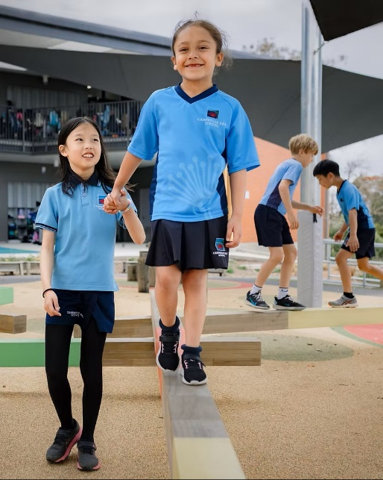
The Campbells Bay Primary School Board, in consultation with their staff and students have set the following appointment criteria for the Deputy Principal.

We are looking for a Deputy Principal who:
- Is an experienced and capable strategic leader
- Is passionate about working in a multicultural environment
- Has expertise in leading digital capability
- Fosters a positive school culture and values a student-centred approach
- Values collaboration and inclusiveness
- Has an in-depth understanding of cultural capability and inclusiveness
- Has strong communication and collaboration skills
- Has knowledge of the changing New Zealand Curriculum and a broad pedagogical knowledge
- Can provide mentorship and grow staff capability

- Is organised, a team player and values professionalism
- Has a sense of humour and fun



INFORMATION FOR APPLICANTS

Thank you for applying for the position of Principal of Campbells Bay Primary School.
Please ensure you have a copy of the job description, the appointment criteria and have read all material provided, before completing the separate application form.
- Please fully complete the application form personally. Read it through first and then answer all questions. Make sure you sign and date where indicated.
- Attach a Curriculum Vitae (CV) containing any additional information relevant to the position. Please ensure your CV addresses the Criteria for Appointment. If you include written references, please note that we may contact the writer of the reference.
- Copies of qualification certificates should be attached. If successful in your application, you will be required to provide the originals as proof of qualifications. These will be needed to verify the copies which will be retained for the school’s records.
- If you are selected for interview, you may bring whānau/support people at your own expense. Please let Nicky Knight know when she finalises the interviews with you, if this is your intention.
- Failure to complete this application and answer all questions truthfully may result in any offer of employment being withdrawn or appointment being terminated if any information is later found to be false.
- All applicants will be required to give consent to a Police Vet (if required).
- a) Applicants may not be employed as a children’s worker if they have been convicted of a specified offence listed in Schedule 2 of the Children’s Act 2014, unless they obtain an exemption. The Criminal Records (Clean Slate) Act 2004 will not apply to these specified offences and these offences will be included in your Police vetting results.
b) The Clean Slate Act provides certain convictions do not have to be disclosed providing:
- you have not committed any offence within seven consecutive years of being sentenced for the offence;
- you did not serve a custodial sentence at any time;
- the offence was neither a specified offence under the Clean Slate Act 2004 nor a specified offence under the Children’s Act 2014;
- you have paid any fine or costs.
Please note that you are not obliged to disclose convictions if you meet the above conditions but can do so if you wish. If you are uncertain as to whether you are eligible contact the Ministry of Justice.

- Application forms and CVs of unsuccessful applicants will be held until the appointment process is completed and will then be securely destroyed after 90 days. For the successful candidate these documents will be held in their personnel file. The successful candidate may access it in accordance with the provisions of the Privacy Act 2020.
- You are required to request reports from three referees. The report template is included in this pack as a separate attachment. It is your responsibility to contact referees and provide them with a copy of the report template and the information that they need to complete and return it. These remain confidential to The Education Group Ltd and the Board. All information collected from referees will be destroyed at the end of the selection process.
- All information received will be confidential to the Board and The Education Group Ltd.
- We encourage you to visit the school. To arrange a suitable time, please contact Bevan Verryt (Principal) 09 410 7444

If shortlisted, you will be required to bring to your interview, the originals and copies of the following:
1. Your current Practising Teacher Certificate
2. Two types of identification:
- If possible, this should be photo ID e.g. passport and a NZ Driver Licence
- If you do not have one or other of the above documents, please supply a birth certificate, bank statement or IRD number


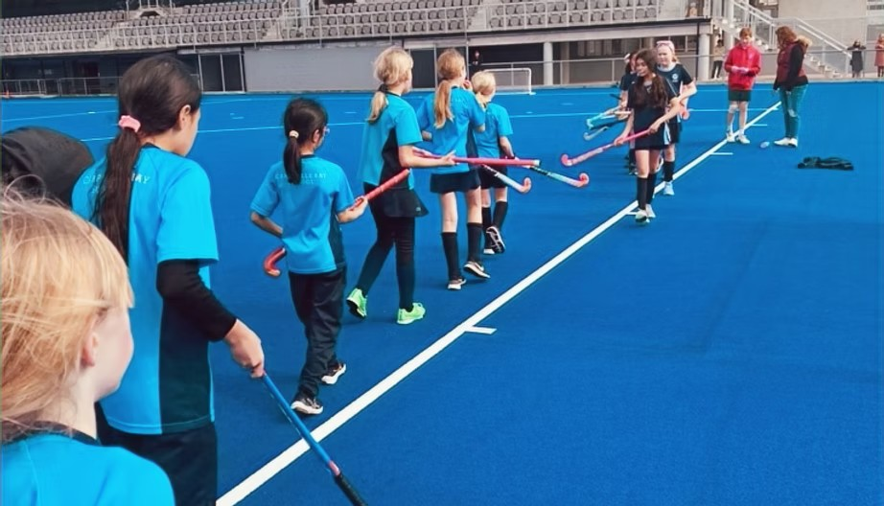

RECRUITMENT PROCESS TIMELINE
We need to receive:
- Letter of introduction
- Completed Application Form
- Your Curriculum Vitae that addresses the criteria for appointment
- Reports from three referees (applicant to organise)

Completed applications to be received by
1:00 pm Monday 17 November 2025

Email to: Tanya Prentice admin@educationgroup.co.nz

Subject line: Campbells Bay Primary School, Deputy Principal Appointment
Or deliver to: The Education Group Ltd, Level 2, 24 Manukau Road, Epsom, Auckland

Education Gazette advertisement-online | 29 October
Candidates visiting Campbells Bay Primary School | 12 – 14 November
Closing date for referee reports | 1:00 pm 17 November
Closing date for applications | 1:00 pm 17 November
Shortlisting – candidates notified by… | 18 November
Visits to shortlisted candidates’ schools | 19 – 21 November
Interviews with applicant’s presentation  The Board reserves the right for second interviews to be conducted if needed | 29 November
Appointment commences | Term 1 2026 unless otherwise negotiated

If you have any queries, please contact: Tanya Prentice, the Office Manager for The Education Group at admin@educationgroup.co.nz or 09 953 0523 or Karen Smith, the Appointment Advisor at karensmith@educationgroup.co.nz or 027 202 4211
Again, we welcome applicants to visit our school and to connect with our staff and students.
To arrange a suitable time, please contact Bevan Verryt (Principal) Phone: 09 410 7444

DEPUTY PRINCIPAL’S JOB DESCRIPTION
ROLE TITLE: Deputy Principal
RESPONSIBLE TO: The Principal of Campbells Bay Primary School
DIRECTLY RESPONSIBLE FOR: The students and school staff (teachers, support, ancillary, property staff)

Leadership capability | Actions | Key Performance Indicators
Building and sustaining high trust relationships | - High trust relationships are built and sustained with all stakeholders.  - These relationships are based on credibility relating educational expertise, treating others respectfully, openness, and self-awareness.  - Leaders build and maintain a network of supportive-challenging relationships within and beyond the organisation. | - Maintains and builds positive relationships through effective communication with all stakeholders.  - Always maintains confidentiality.  - Provides relevant and up to date information to the principal to assist with the effective day to day management and strategic direction of the school.
Ensuring culturally responsive practice and understanding of Aotearoa New Zealand’s cultural heritage, using Te Tiriti o Waitangi as the foundation | - Embedding cultural competencies school wide.  - Ensures their own understanding of what culturally responsive practice based on Te Tiriti o Waitangi means in practice, and why.  - Support all staff to develop and sustain a shared understanding of culturally responsive practice based on Te Tiriti o Waitangi. | - Supports staff to deliver culturally responsive learning based on Te Tiriti o Waitangi.  - Is able to evaluate and improve the quality of learning in the school based on this culturally responsive practice.  - Supports staff in their professional learning of culturally responsive practice.  - Works with whanau and iwi to ensure a culturally responsive pedagogy.
Building and sustaining collective leadership and professional community | - Uses their educational expertise to develop leadership by:  - drawing on individual and collective strengths  - providing opportunities for others to actively contribute to initiatives and extend their knowledge and skills  - ensuring that problems impeding learning and wellbeing are identified and addressed | - Leads and supports all staff to improve their skills in teaching and learning.  - Acts as a professional role model for staff.  - Acknowledges and deals directly on issues relating to the professional standards.  - Keeps up to date with current management and professional practice.  - Participates as an effective member of the senior management team.  - Actively supports decisions taken by the principal and /or Board.
Strategically thinking and planning | - Contributing to strategic planning and review  - Works closely with leaders to support schoolwide strategic priorities | - Supports the Principal and Board in the development, implementation and review of the strategic plan.  - Regular consultation and meetings with staff.
Evaluating practices in relation to outcomes | - Ensures there is robust and best practice schoolwide, specifically:  - curriculum content, progress and engagement of learners and student wellbeing.  - Modelling strong data literacy theory and practice.  - Identify and monitor areas of need and allocation of appropriate resources. | - Assist with school wide data review to inform next steps and strategic planning.  - Ensuring robust moderation practices takes place.  - Assist with data reports to the Board.  - De-aggregation of data of Maori, Pacific student achievement takes places to measure progress and achievement to compare against other ethnicities and inform next steps.
Adept management of resources | - Supports strategic allocation of resources.  - All actions and practice are in line with school policies.  - Ensures that staff feel valued and supported.  - Staff are supported through their Professional Growth Cycle.  - Works with staff to make the most effective and efficient use of time, space, physical and material resources.  - Active participation in local networking groups.  - Assist in recruiting highly performing staff.  - Maintains a positive relationship with all stakeholders. | - Manages resources so that they align with the school’s strategic direction.  - Ensures that school policies are adhered to.  - Assist staff to ensure that the PGC guidelines are followed.  - Encourage staff to fully participate in professional development opportunities.  - Encourages and provides opportunities for staff to reflect on and discuss effective teaching and learning practices with each other  - Actively seeks the views of others; maintains open communication  - Encourages staff to take on challenges and take risks with their professional learning
Attending to their own learning as leaders and their own wellbeing | - Keep current with new evidence and research-based knowledge.  - Fully engages with an external PGC consultant for continued personal growth.  - Maintains professional relationships. | - Shares current educational research, practice and professional development with staff.  - Acts as a role model for staff with their own professional learning  - Strives for continual improvement.
Embodying the organisation’s values and moral purpose, optimism, agency and resilience | - Treats all stakeholders with respect and consistently models the school values.  - Shows and models resilience.  - Thinks of new actions within their sphere of influence and works with and supports staff who want to try new things that would advance the organisation's vision and goals | - Actively supports decisions taken by the principal and /or Board.  - Displays optimism, determination and resilience and models this to all stakeholders.  - Actively supports new initiatives that advance the school’s vision and goals.  - Supports and contributes to a positive school culture.
Contributing to the development and wellbeing of education beyond their organisation | - Contributes to the building of new knowledge to improve teaching and learning, and equity of educational outcomes | - Works In collaboration with colleagues within and beyond the school to help develop and grow best practice to improve outcomes for our learners
Digital Literacy Leadership | - Ensure effective use of all digital resources e.g.  - Chromebooks/ipads  - VR cameras  - STEM resources  - Online apps  - Canva  - Schoolzine  - eTAP  - Linewize  - Seesaw  - Google School | - Works alongside staff to ensure digital literacy is strong across all year level.  - Lead PLD for all stakeholders e.g. parent workshops, staff workshops, student digital leaders.  - Develop innovative programmes to maximise the use and application of digital devices and software.
Day to day operation of the school | - Working alongside the senior team in the day to day running of the school  - Oversee staff absence, relievers and release as needed e.g. CRT, PLD  - Leading designated team/teams as the go to deputy principal.  - Oversees school promotion through website, local newspapers, social media  - Appraisal of office staff | - Contributing to the running of an effective and successful school.  - The staff and community are informed in a timely manner about events that will affect them.  - Maintain and share release documentation to ensure teachers receive entitled release (e.g. CRT, PRT, team leader, curriculum leader  - Organise relievers as needed  - Documentation for appraisal completed. Goals and outcomes shared with the principal.
Curriculum Management | - Active participation in the ongoing development, implementation and review of the NZ curriculum  - Oversees schoolwide Inquiry Learning  - Oversees student Health and Wellbeing | - Initiate overviews and long-term planning for Inquiry Learning  - Monitors and provides information on student wellbeing through surveys.  - Regularly monitors teacher planning of designated team/s.  - Models best practice in classrooms when needed.
Student Leadership | - Leading and developing the following student leadership areas  - House Captains  - Students Coaches  - Assemblies  - School events  - Supports staff who lead these student leadership areas such as:  - Sports leaders  - Enviro Leaders  - Road Patrols  - Cultural leaders  - Librarians | - Coordinate and prepare House Captains to run assemblies and school events, welcome visitors  - Ensure student leaders receive development opportunities e.g. training in public speaking and the Wellington trip.


