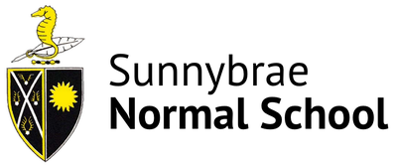
Sunnybrae Normal School 2025
Self-Assessment for Principal Position

Please complete this self-assessment and return it with your application form and CV by 3:00 pm Wednesday 4 June. Please feel welcome to use bullet points. Please write between a half page and nor more than a page for each question.

School Culture: Our positive school culture, built on a strong sense of ‘community’, is a key feature of our school. What will you do to maintain and build on this?

Change Leadership. Describe a change process that you have recently led at your current school. Talk about the process that you went through and the outcome. What did you learn?

Normal School: As the Principal how would you continue to enhance our Normal School Status and what do you see as the benefit of doing this?

